**Week 6: 22 Aug 2022 to 28 Aug 2022**

**Unit 3.2 Logic Gates and Logic Circuits**

**Class Activity 1**

1) What is the output at Q ?

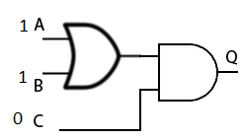

2) Which logic gate can be represented by this truth table ?

|  |  |  |
| --- | --- | --- |
| **Input A** | **Input B** | **Output** |
| 0 | 0 | 0 |
| 1 | 0 | 1 |
| 0 | 1 | 1 |
| 1 | 1 | 0 |